VPN Client

To install the VPN Client, double-click on the client installer on the CD (32bit or 64bit).

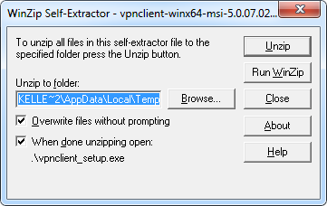

Click unzip

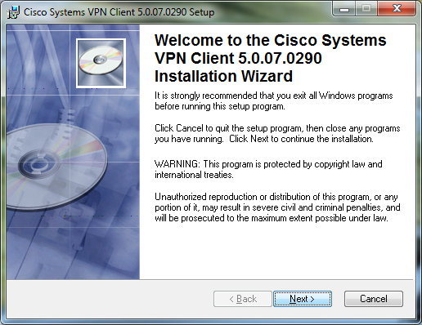

When the installer wizard appears click next through all the windows. It will take a couple minutes to install and requires a system restart.

(If you are running Windows 8, click on the file called “Windows 8 VPN Fix” and accept all the prompts)

After you restart your PC open the VPN Client software: Start 🡪 Programs 🡪 Cisco Systems VPN Client 🡪 VPN Client

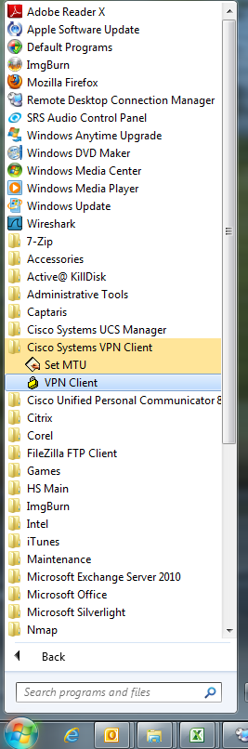

When the client opens click on Import and select the Cork-RSA-2011.pcf file included.

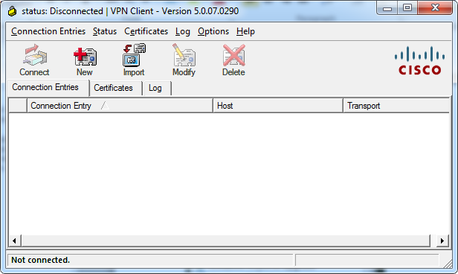

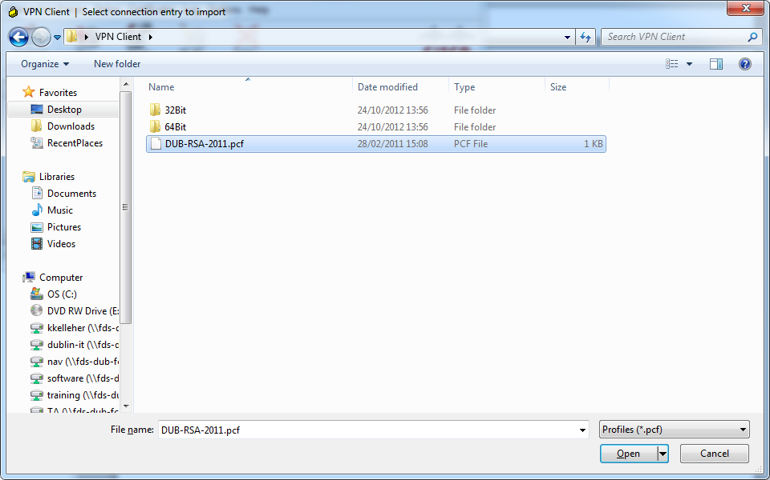

# Signing in using iPhone / Android

After the config file has been imported click on connect. On your phone, open the RSA SecureID app and enter 0000 as the PIN. In User Authentication windows seen below enter your username and the 8 digit passcode generated in the RSA SecureID app. You will then be asked to create a PIN; this will need to be between 4 and 8 digits

When you have created your PIN you will be prompted to log in once more. This time on the app on your phone enter your newly created PIN. Enter your username and the 8 digits on your phone into the User Authentication window and click OK.

# Signing in using Token Fob

After the config file has been imported click on connect. The below prompt will come up. Enter your username and the 6 digit passcode on the fob. You will then be asked to create a PIN; this will need to be between 4 and 8 digits

When you have created your PIN you can log in. Enter your username, your passcode will be your PIN followed by the 6 digit code on the fob.

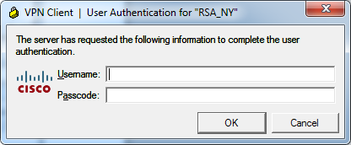

Once the window disappeared you have successfully connected and can Remote onto your PC.

To remotely connect to your PC click Start 🡪 Programs 🡪 Accessories 🡪 Remote Desktop Connection

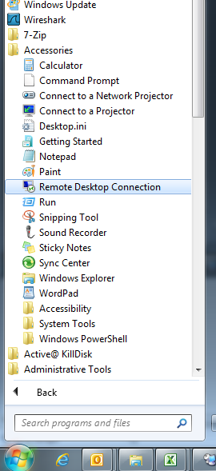

Enter your PC name in the prompt that pops up and press connect

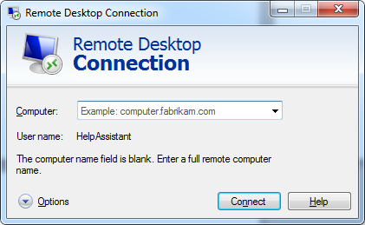

When prompted for your username, place “FDS\” before your name as seen below

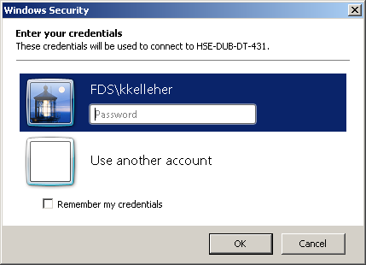

When you are finished close your remote window and right click the yellow lock on the bottom right of your screen beside the clock and select Disconnect

